Analyzing Economic Growth in Bangladesh and Malaysia (2012–2022): A Production Function Approach Using GDP and Capital Formation in Current Prices

**Introduction**

Economic expansion constitutes a fundamental objective for nations, with comprehending its determinants being crucial for policy architects and academic investigators. The production function serves as a prevalent analytical framework for economic growth, elucidating how productive factors such as capital and labor contribute to a nation's economic output, typically quantified as GDP. This research investigates the correlation between GDP and capital formation in Bangladesh and Malaysia over 2012-2022. The inquiry utilizes data extracted from the WDI, concentrating on GDP and GFCF, both denominated in current LCU. The methodological approach employs a log-log production function, enabling the estimation of GDP elasticity concerning capital.

The empirical methodology employs Stata for statistical analysis, with variables logarithmically transformed for regression analysis. Subsequently, the model is augmented with additional explanatory variables—exports, imports, literacy, and mortality—to enhance its descriptive power and elucidate economic growth's multifaceted determinants.

This comparative study aims to elucidate the differential impacts of investment and other economic factors on output in both countries, providing insights into their developmental trajectories over the last decade.

**Bangladesh and Malaysia (2012–2022)**

We estimate the following log-linear model:

$$ln(GDP)=β0​+β1​⋅ln(capital)+ε$$

The regression results (from Stata) give:

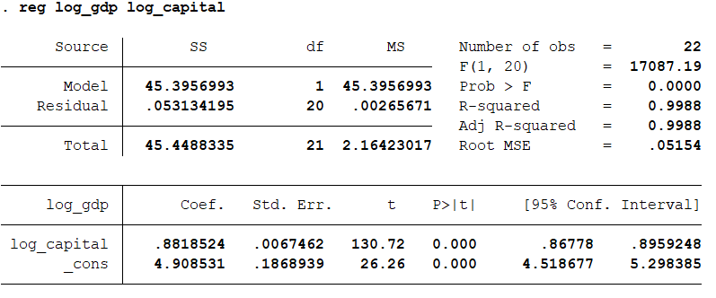  
  
This suggests that capital has a strong positive effect on GDP. When fixed capital increases by 1%, GDP increases by about 0.88%, on average. This relationship holds across all observations meaning it’s the average effect for Bangladesh and Malaysia, pooled together. The F-statistic tests whether your model (with the predictor log_capital) explains significantly more variation in log_GDP than a simple average (constant-only) model. Here, 17087 is a very high value, meaning predictor is very powerful. This is the p-value for the F-test: here, 0.0000 the model is statistically significant. It means it’s extremely unlikely the relationship you see is due to random chance. log(GDP) in model explains. 0.9988 means 99.88% almost all the variation is explained by log(capital). This adjusted R² = 0.9988 still extremely high.

**Variance Inflation Factor (VIF) test**

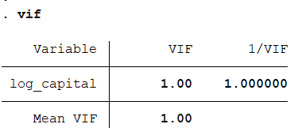

A VIF of 1.00 indicates that there is **no multicollinearity** detected for the log_capital variable in the model. Multicollinearity occurs when two or more predictor variables in a regression model are highly correlated, which can make it difficult to interpret the individual effects of each predictor.

**Breusch-Pagan Test**

This test formally examines whether the variance of the residuals in your regression model is constant (homoskedasticity) or changes systematically with the fitted values of the dependent variable (log_gdp in this case). The p-value of 0.0442 is less than the conventional significance level of 0.05. Therefore, we reject the null hypothesis of constant variance.

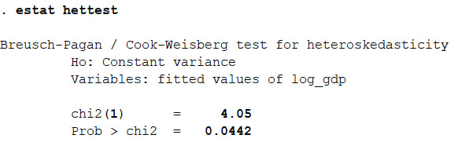

**Prob > chi2 = 0.0442** This is the p-value associated with the chi-squared test statistic.

The distribution appears unimodal with a central tendency slightly shifted to negative residual values, indicating a potential tendency for the model to overpredict. While the bulk of the residuals are clustered around zero, the distribution exhibits a slight positive skew, with a longer tail extending towards positive residual values, suggesting the presence of some larger positive prediction errors. The spread of the distribution indicates the overall variability of the model's errors. Although roughly bell-shaped, the observed skewness suggests a deviation from a perfectly normal distribution of the residuals.

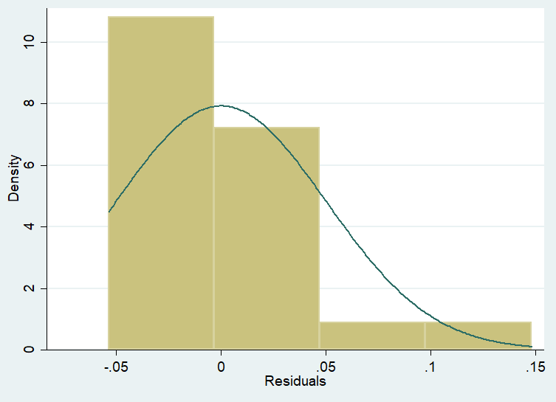

**Skewness/Kurtosis tests**

The skewness test for this regression residuals yielded a p-value of 0.0095. Since this value is less than the conventional significance level of 0.05, reject the null hypothesis of zero skewness. This indicates that the distribution of residuals is significantly skewed.

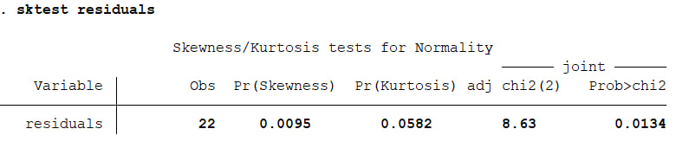

Specifically, based on the earlier histogram which showed a longer tail on the right side, residuals exhibit positive skewness (also known as right skew). This means that the distribution of the model's errors has a tendency to have more extreme positive values compared to a symmetric distribution. In practical experiencing some larger positive prediction errors more frequently than large negative errors.

**Ramsey Regression Equation Specification Error Test (RESET)**

The test examines whether the linear regression model has omitted relevant variables or an incorrect functional form by adding powers of the fitted values of the dependent variable, log_gdp, to the original model. The null hypothesis is that the model has no omitted variables.

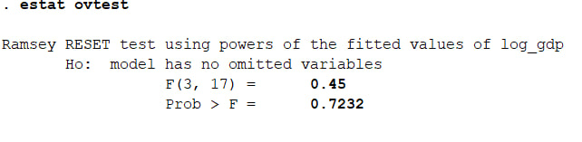

The calculated F-statistic is 0.45, with 3 degrees of freedom in the numerator and 17 in the denominator. The associated p-value is 0.7232.Since the p-value (0.7232) is considerably larger than the conventional significance level of 0.05, the null hypothesis is not rejected. Based on the Ramsey RESET test, there is no statistically significant evidence to suggest that the model suffers from omitted variables or an incorrect functional form. The test does not provide enough evidence to conclude that adding powers of the fitted values of log_gdp significantly improves the model's fit. This suggests that, according to this specific test, the simple linear model does not appear to have significant issues with omitted variables or functional form detectable through this method. However, it remains important to consider economic theory and other diagnostic tests for a comprehensive model evaluation.

**Economic Interpretation**

This analysis applies a production function approach, regressing the logarithm of GDP ($loggdp$) on the logarithm of gross capital formation ($logCapital$) using panel data for Bangladesh and Malaysia over the period 2012–2022. The purpose is to understand the contribution of capital accumulation to economic growth in these two emerging economies.

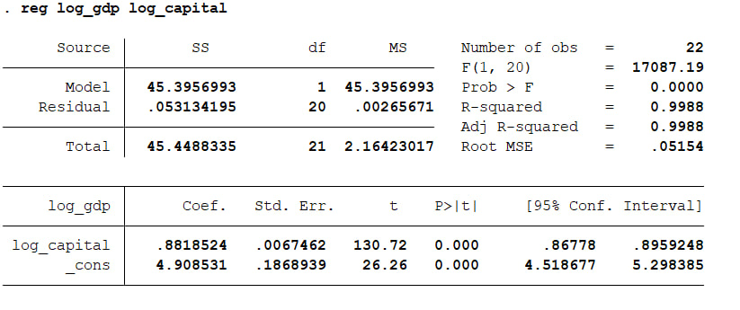

**Strong Positive Relationship Between Capital and GDP**

The regression results show that the coefficient on $logCapital$ is 0.8819. This means that, holding other factors constant, a 1% increase in capital formation is associated with approximately a 0.88% increase in GDP.

This finding aligns well with economic theory. In the Cobb-Douglas production function, the elasticity of output with respect to capital reflects how much output responds to changes in capital inputs. An elasticity below 1 suggests diminishing returns to capital, meaning that while increasing capital boosts GDP, each additional unit of capital adds slightly less to output compared to the previous unit.

In both Bangladesh and Malaysia, this highlights that while capital accumulation is essential, relying solely on capital deepening may not be sufficient for long-term growth without improvements in labor productivity, human capital, or technological advancement**.**

**High Explanatory Power of Capital**

The R-squared value of 0.9988 indicates that nearly 99.88% of the variation in GDP across the sample is explained by capital formation. This is exceptionally high, suggesting that capital formation has been the dominant driver of GDP growth in both countries over this decade.

While this shows capital’s critical role, such a high R-squared also raises some caution. It may signal that the model is overfitting the data or omitting other important variables like labor force growth, human capital, or productivity factors (total factor productivity, TFP). In reality, economic growth is multifaceted, and capital is just one part of a broader growth strategy.

**Statistical Significance and Robustness**

The t-statistics for both the $logCapital$ coefficient (130.72) and the constant term (26.26) are extremely high, and the p-values (0.000) confirm that these estimates are statistically significant at any conventional level (1%, 5%, 10%).

This robustness gives confidence that the relationship between capital and GDP is not due to random chance but reflects a strong empirical pattern across both economies during the observed period.

**Policy Recommendations**

both countries should:

1. Continue supporting capital investment but focus on quality, not just quantity. Investments should target productive sectors, infrastructure, and technology-intensive industries.
2. Enhance human capital through education, training, and health improvements to complement physical capital.
3. Boost total factor productivity (TFP) by investing in innovation, research and development, and institutional improvements.
4. Diversify growth strategies beyond capital accumulation to include exports, services, and digital economy initiatives.